- To begin signup:
- Click Register/Login, and then create account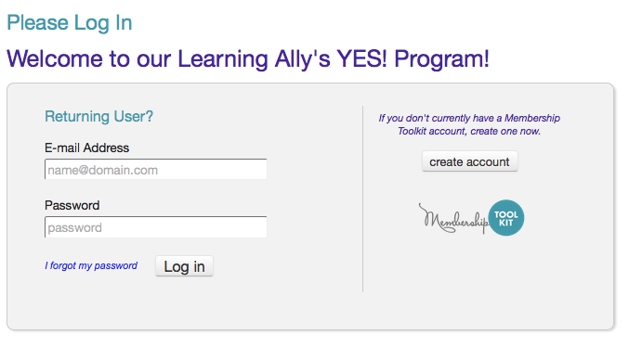
- Create a Membership Toolkit account with first name, last name, email, and password 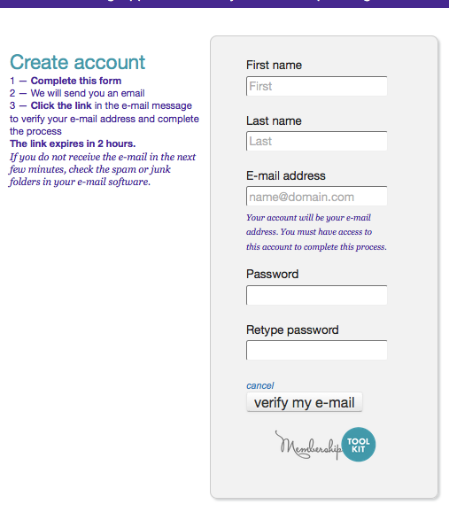
- Verify account through new account email verification within two hours of creating your account: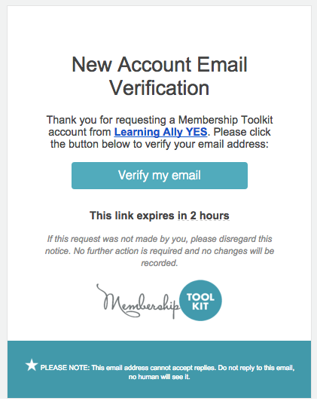
- You will now be brought to your account home – click on ‘Become a Member!’ to proceed: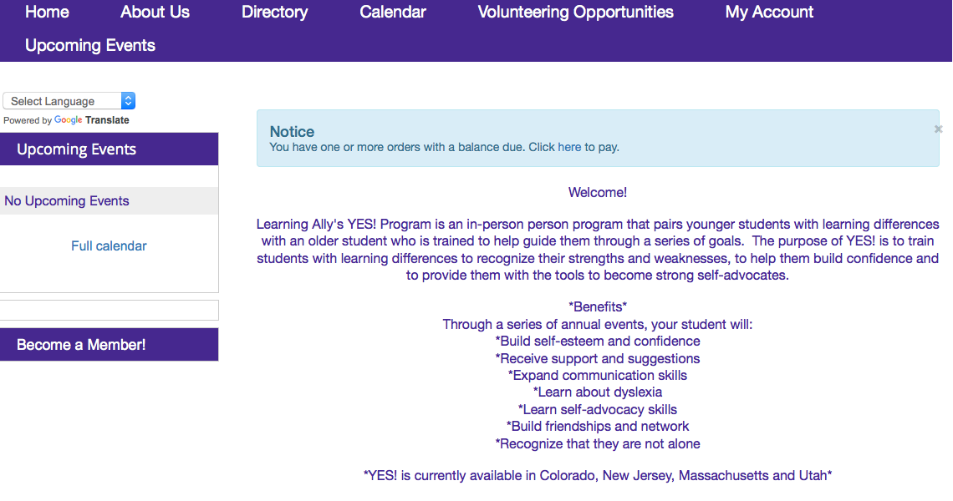
- Fill out parent information: 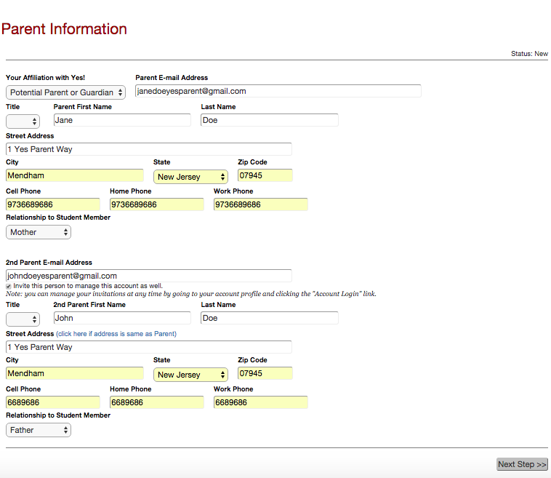
- Add student info (can be more than one student) 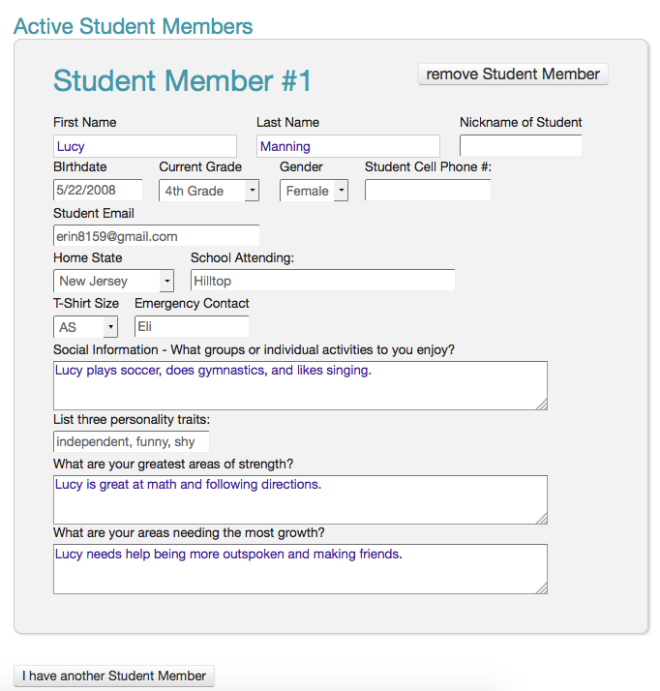
- Submit publishing permissions. The following fields may be made public or kept private:
- 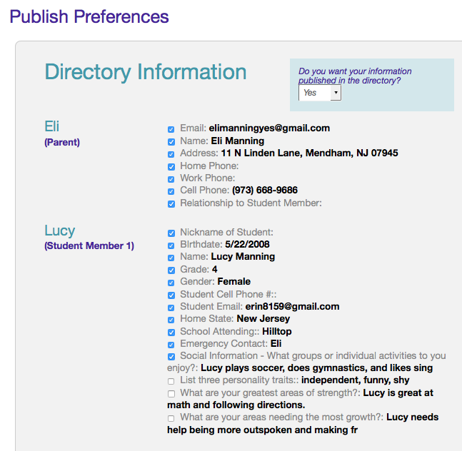
- 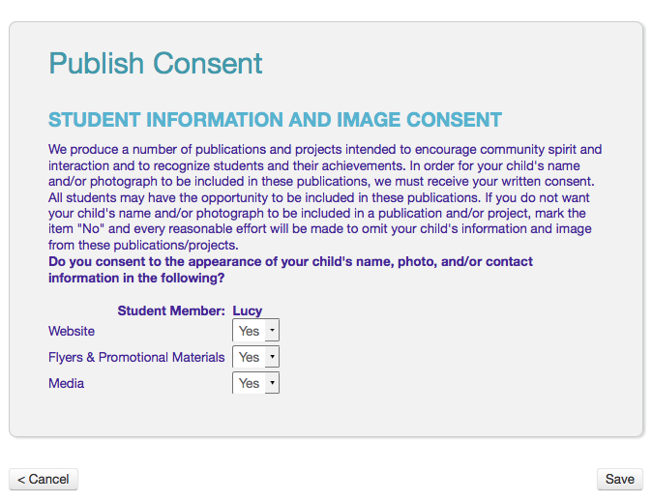
- Parent and student sign code of conduct add membership to cart to checkout
- 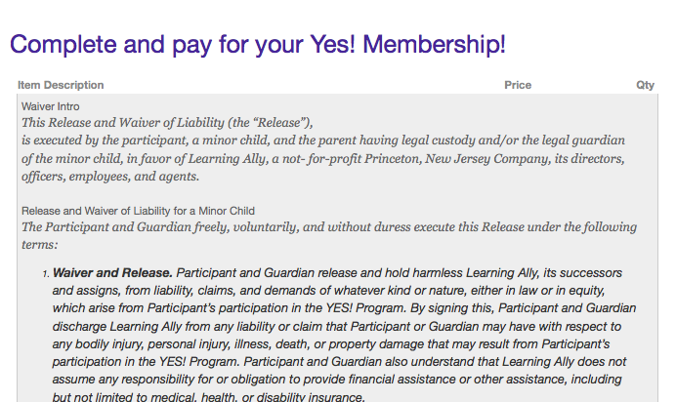
- 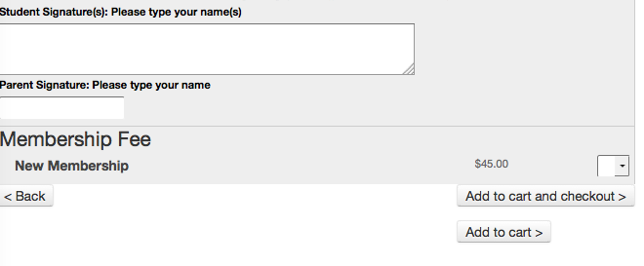Parent is brought to checkout page and either Pays with PayPal (credit card or PayPal account)

